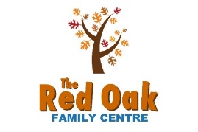
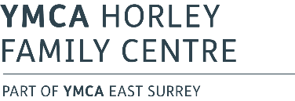

Christmas & New Year Closure
The Reigate & Banstead partnership Family Centres will be closed between Christmas and New Year. Welcare duty worker available 29th, 30th and 31st December on 07493 867679
If you need emergency support during this time the following organisations are available:
Children’s Services: If you are concerned about the safety of a child or young person you can contact the Surrey Children’s Single Point of Access on 0300 470 9100.

Mental Health Support:
Safe Haven: This is a drop-in service. No phone number is available. Open for people experiencing a mental health crisis 6pm-11pm, 365 days a year. Redhill: Wingfield Resource Centre, St Anne's Drive, Redhill, RH1 1A Epsom: The Larches, 44 Waterloo Road, Epsom, KT19 8EX Safe Havens :: Surrey and Borders Partnership NHS Foundation Trust (sabp.nhs.uk)
24hr NHS helpline: 0800 915 4644
Samaritans: 116 123
Practical Support:
Food Bank: For emergency referrals. Contact Citizens Advice on 0800 144 8848 or Reigate & Banstead Borough Council. (see below)
Reigate & Banstead Community helpline: 01737 276000 or SMS text 07834 624468 (in emergency, outside of office hours call 0151 221 2938)
Raven Housing Trust: 0300 123 3399
Children and Family Health Surrey 0-19 advice line: 01883 340922
Domestic Abuse:
If you are being frightened, hurt or abused by a partner or family member call:
East Surrey Domestic Abuse Services: 01737 771350
Surrey Domestic Abuse Helpline: 01483 776822
24hr National Domestic Abuse Helpline: 0808 2000 247
Domestic abuse is a crime. Call 999 if you feel your life is in immediate danger.
We would like to take this opportunity to wish you all a very Merry Christmas and a happy new year!

